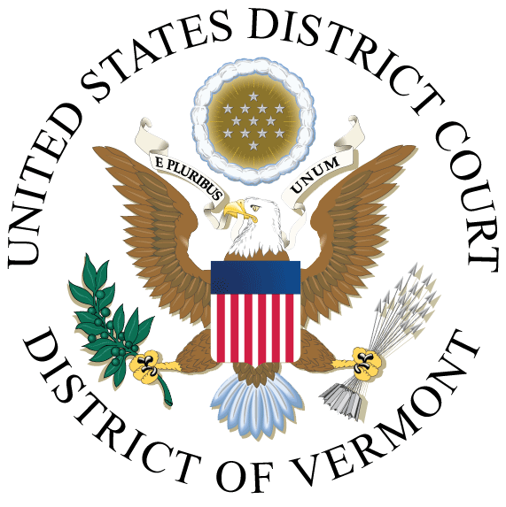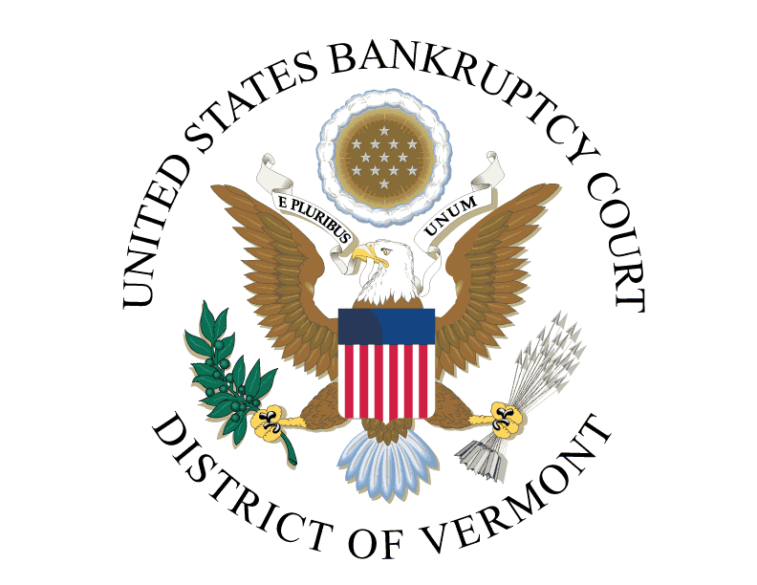

PUBLIC NOTICE OF CLOSURE

Due to the holidays, the Clerk's Offices (all locations) will be closed on the following dates:

Monday, December 24, 2018
Tuesday, December 25, 2018
Monday, December 31, 2018
Tuesday, January 1, 2019

The court's Electronic Case Files (ECF) and Public Access to Court Electronic Records (PACER) systems will remain operational during the closure.

JEFFREY S. EATON
CLERK OF COURT

