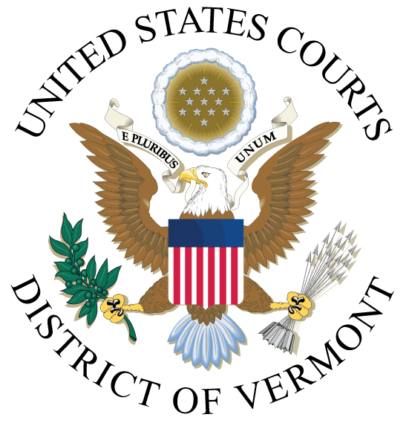

PUBLIC NOTICE OF CLOSURE

Due to the holidays, the Clerk's Offices (all locations) will be closed on the following dates:

Thursday, December 23, 2021
Friday, December 24, 2021
Thursday, December 30, 2021
Friday, December 31, 2021

The court's Electronic Case Files (ECF) and Public Access to Court Electronic Records (PACER) systems will remain operational during the closure.

JEFFREY S. EATON
CLERK OF COURT

